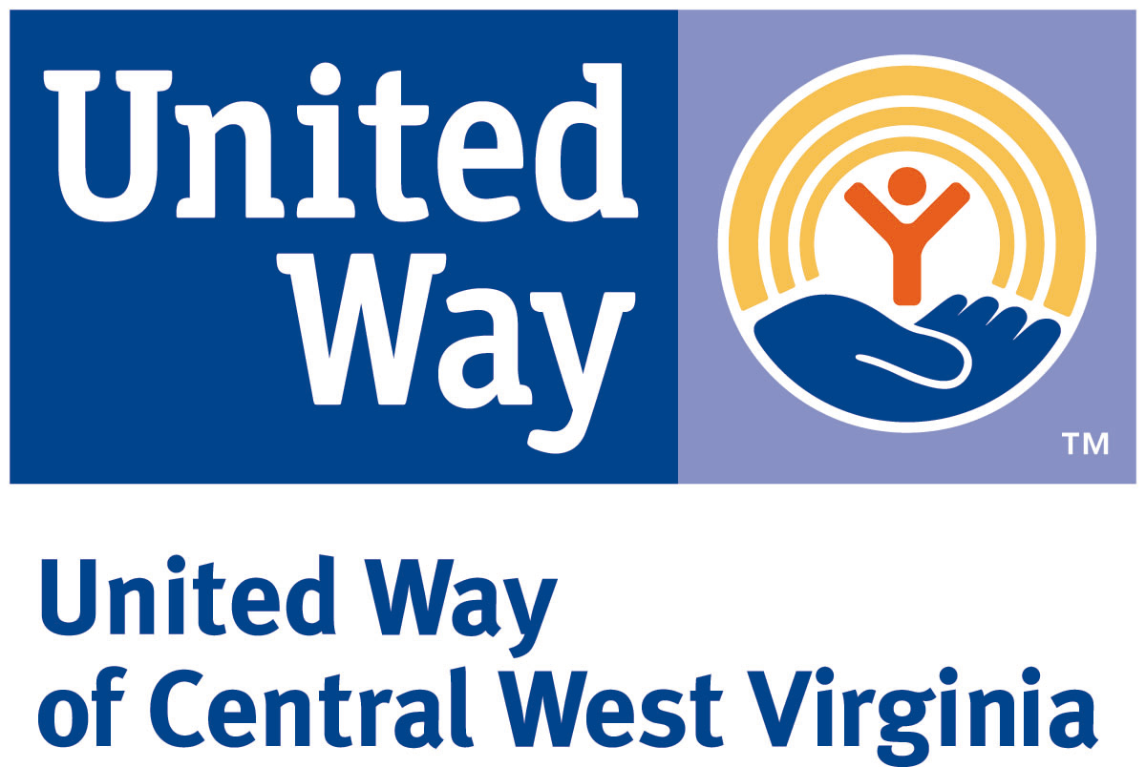
United Way of Central WV
Letter of Intent Guidelines

ELIGIBILITY TO APPLY
Do not submit a Letter of Intent unless all of the following conditions apply. The organization:
- Is an incorporated nonprofit organization and has tax-exempt status under section 501(c)(3) of the Internal Revenue Service code.
- Has a Board of Directors that is an active, representative voluntary governing body, with regular meetings and is responsible for developing its mission, determining its strategic direction and providing oversight.
- Has up-to-date, current bylaws, or guidelines, by which the organization operates.
- Can provide, when requested, a financial audit (if organization revenue is over $500,000), a financial review (if organization revenue is greater than $200,000 but less than $500,000) or a financial compilation (if organization revenue is below $200,000). Financial audit, review or compilation must be performed by an independent certified public accountant in compliance with generally accepted accounting standards as applied to non-profit organizations. (Note: revenue determination is from all sources except government grants and grants from private foundations).
- Files an IRS form 990, including schedule A or 990 EZ, or can document the circumstances under which the 990 filing is waived.
- Serves one or more counties in United Way of the Central WV service area – Boone, Clay, Kanawha, Logan and Putnam counties.
- Has the mechanisms and capacity for regularly reporting measurable, qualitative and quantitative outcomes.
- Demonstrates reasonable efficiency in program management and adequacy of resources, both in materials and in personnel (voluntary and paid) to sustain a quality level of service.

PROCESS
- Submit Letter of Intent (LOI) and 501(c)(3) IRS determination letter by 5 p.m. January 8, 2019 online. Click “Apply” on the home page to begin the application process. Late or incomplete applications will not be reviewed.
- Each program may submit one Letter of Intent. A separate Letter of Intent must be completed for each program for which the organization is requesting funding.
- At least one United Way of Central WV outcome must be addressed.
- Programs that use evidence-based practices will be given higher preference.
- If this is a collaborative effort, the lead 501(c)(3) organization should complete the LOI.
- Minimum grant request is $5,000 and maximum is $50,000.
- Funding is not provided for: national or statewide proposals; agency operating costs not directly associated with a specific program; annual campaigns or membership drives; acquisition or expansion or real estate/building; capital expenditures.
- Eligible organizations proposing projects that are the most closely aligned with United Way of Central WV’s impact areas and outcomes will be invited to submit a full grant application. If invited, the full grant application will be due March 1, 2019 by 5 p.m.
- Citizens Review Teams, made up of trained community volunteers and donors, review all LOI’s and funding applications. The Citizens Review volunteers make funding recommendations to the UWCWV Board of Directors who are responsible for all final decisions. Funding announcements will be made in July of 2019 and funding will begin January 1, 2020.
- Organizations that are awarded grants are required to submit a six-month outcomes report and an end of year outcomes report and beneficiary data.

2019 Impact Areas, Program Categories and Outcomes

Education:
1. Quality Childhood Education and School Readiness
- Children will achieve developmental milestones and will be ready to benefit from social, emotional, and
cognitive development activities provided at the next level of education

2. Academic Success
- At-risk youth will maintain or increase their academic performance
- At-risk youth will increase life skills

3. Parent/Caregiver Development
- Parents/caregivers will strengthen their parenting skills
- Parents/caregivers and children will have more frequent, positive interactions and communication
- Parents/caregivers will actively support their children’s academic growth

Financial Stability:
1. Transportation
- Individuals will have transportation to obtain job-related training or employment

2. Employment Readiness
- Individuals will complete job training programs that result in “work ready” employees
- Individuals will learn the “soft” skills needed to gain and maintain employment
- Individuals will obtain employment
- Individuals will maintain employment

3. Financial Literacy
- Low-income individuals will develop financial literacy skills to manage financial resources effectively
- Low-income individuals will use knowledge and skills to manage financial resources effectively

Health:
1. Alcohol and Drug Abuse
- Reduce substantial use among youth and/or adults using evidence-based substance abuse prevention programs
- Reduce substance abuse among youth and/or adults
- Increase youth and/or adults maintaining sobriety and self-sufficiency

2. Affordable Healthcare
- Uninsured and underinsured individuals will obtain essential medical and dental care
- Reduce poor health outcomes resulting from smoking, obesity, diabetes, and other health issues

3. Affordable Mental Health Counseling
- Individuals and families will receive ongoing and crisis counseling to help them increase mental wellbeing

4. Health and Wellness
- Individuals will engage in healthy, prevention activities (defined by the program) to increase their health and
wellbeing
- Reduce factors that negatively impact the health of community residents, including smoking, obesity and
Diabetes

Safety Net:
1. Domestic Violence and Child Abuse Services
- Survivors’ immediate safety needs will be met
- Survivors will increase their knowledge about domestic violence
- Survivors will increase their awareness of community resources
- Reduce domestic violence in the service area

2. Shelter Services
- Participants will actively engage in supportive services (defined by the program) to move into permanent
housing
- Participants will achieve housing stability

3. Access to Food
- Reduce food insecurity for low-income individuals and families

4. Aging in Place for Seniors
- Seniors will live independently and safely in their own homes

5. Disaster Relief
- Individuals affected by disaster will have their immediate basic needs met
- Individuals affected by disaster will be assisted in finding resources/services to help them achieve pre-
disaster status
- Increase community knowledge to prepare for and respond to disasters

6. Rent and Utility Assistance
- Individual’s immediate basic housing needs will be met
- Individuals will be assisted in finding resources/services/programs to help them address their financial stability.

